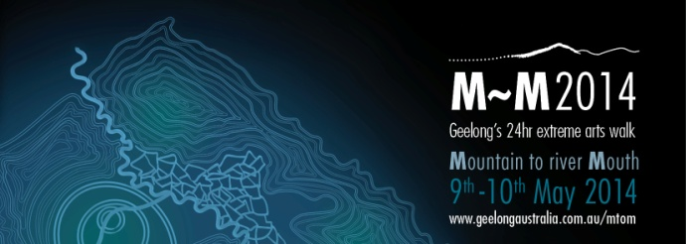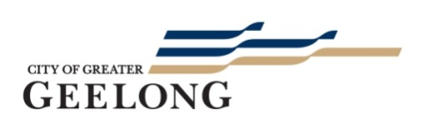

Sample – Generic Media Release

Mountain to Mouth (M~M2014) is a cultural beacon for the Geelong region. In these times of great change, M~M2014 is an innovative cultural event, gathering together people from all walks of life for a shared journey through the unique landscape of the Geelong region.

M~M2014 is a 24hr extreme arts walk, a biennial pilgrimage from mountain top to river mouth. The journey starts late afternoon on Friday 9th May at You Yangs Big Rock and finishes at dusk on Saturday 10th May at the mouth of the Barwon River.

Initiated by the Arts & Culture Department of the City of Greater Geelong, M~M2014 invites people of all ages and abilities to register to walk one or more stages of an 80km pathway. The walk incorporates a program of music, visual arts, storytelling and sporting elements presented by local and guest artists under the artistic leadership of internationally renowned Meme McDonald, recent recipient of the Ros Bower Award.

M~M2014 will also incorporate ‘Geelong After Dark’ – a vibrant city centre arts event on Friday 9th May from 5pm that will light up Geelong with spontaneous performances, music and art installations.

Funds raised from M~M2014 will support the Karingal Foundation to present inclusive environmental projects along the M~M pathway.

City of Greater Geelong Mayor Darryn Lyons says, “Change is happening rapidly across the Geelong municipality - it’s happening at all levels of community, the economy and across the landscape. M~M is a response to this change, creating links across diverse communities.”

M~M2014 is one of the most unique cultural events this city has seen. Mayor Lyons says, “the M~M idea of establishing a local contemporary ‘songline’ has been nationally recognised for its originality. It’s an exciting addition to the city’s vibrant and ever-expanding cultural calendar.”

Cr Andy Richards, Portfolio Holder for Arts and Culture says, “M~M is based on a pilot journey in 2009, when water was taken from the mouth of the Barwon River and carried by community ambassadors to the top of the You Yangs. “M~M2014 returns the water to the ocean,” said Cr Richards. “Since the pilot there has been broad community demand to bring the journey back as a recurring pilgrimage.”

Everyone is invited to take the challenge and discover the unique landscape and culture of the Geelong region. The walk is open to all, allowing participants to choose to walk either the full distance, or one or more stages. The walk can also be undertaken as a workplace relay. Register today at www.geelongaustralia.com.au/mtom

For schools, community groups and corporate involvement, go to the M~M2014 homepage or contact the Karingal Foundation by phone: 03 5249 8900/03 5249 6365 or email: carolinem@karingal.org or lindalf@karingal.org.au.

Media Enquiries

Teresa O’Brien
P: 0437 363 572

Deb Sansom, Arts & Culture Department, City of Greater Geelong
P: 5272 4985

Note to Editors: Media kit will be available shortly at www.geelongaustralia.com.au/mtom

Follow us on and

M~M2014 Major Partners

Partners

