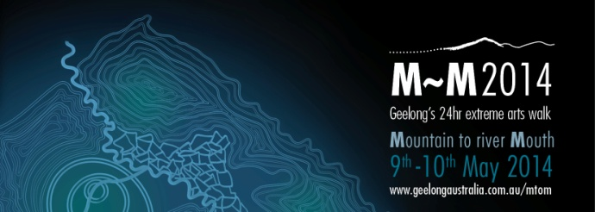

MEDIA DIARY NOTE

‘M~M2014 - Geelong’s Extreme Arts Walk’
From the You Yangs to the Barwon River
9th-10th May 2014

M~M2014 is a 24hr extreme arts walk, a biennial pilgrimage from mountain top to river mouth. The journey starts at 2.30pm on Friday 9th May at You Yangs Big Rock and finishes at dusk on Saturday 10th May at the mouth of the Barwon River.

Register today at www.geelongaustralia.com.au/mtom

Event highlights:

- A walk that is open to all, where participants can do one short leg or the full 80km distance

- 12 stations featuring walking circles, music, visual arts, storytelling and sporting elements

- ‘Geelong After Dark’ – a new and vibrant event that will light up Central Geelong with spontaneous performances, music and art installations on Friday 9th May from 5pm

- Funds raised from M~M2014 will support the Karingal Foundation to present inclusive environmental projects along the M~M pathway

Media Enquiries
Teresa O’Brien Deb Sansom
P: 0437 363 572 P: 5272 4985

Follow us on and

M~M2014 Major Partners

