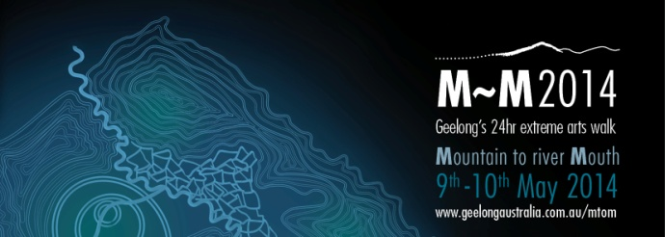

Media Alert

What: M~M 2014

M~M2014 is a 24hr extreme arts walk, a biennial pilgrimage from mountain top to river mouth. The journey starts at 2.30pm on Friday 9th May at You Yangs Big Rock and finishes at dusk on Saturday 10th May at the mouth of the Barwon River.

Register today at www.geelongaustralia.com.au/mtom

When: 9th May 2.30pm – 10th May 7pm

Where: Starts at Big Rock, You Yangs, Lara 3212 - travels to mouth of Jetty Road, Barwon Heads 3227

Enquiries: Teresa O’Brien 0437 363 572
Deb Sansom 5272 4985

Follow us on and

M~M2014 Major Partners

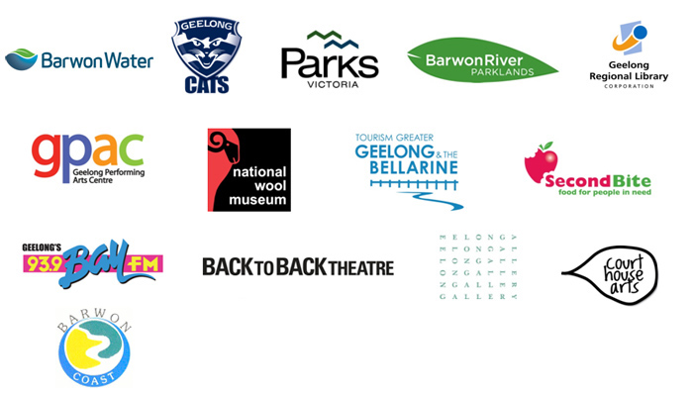
Partners

