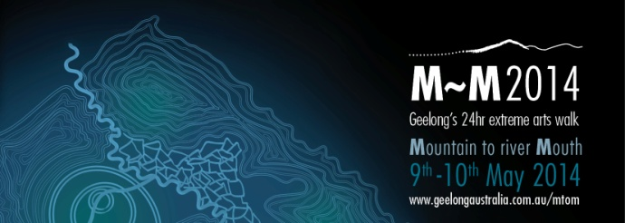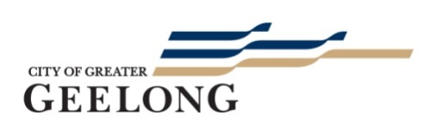

Event Profile

What is M~M 2014?

- Mountain to Mouth (M~M2014) is a cultural beacon for the Geelong region. In times of great change, M~M2014 is an innovative cultural event, gathering together people from all walks of life for a shared journey through the unique landscape of the Geelong region.

- M~M2014 is a 24hr extreme arts walk, a biennial pilgrimage from mountain top to river mouth. The journey starts at 2.30pm on Friday 9th May at You Yangs Big Rock and finishes at dusk on Saturday 10th May at the mouth of the Barwon River.

- Initiated by the Arts & Culture Department of the City of Greater Geelong, M~M2014 invites people of all ages and abilities to register to walk one or more stages of an 80km pathway. The walk incorporates a program of music, visual arts, storytelling and sporting elements presented by local and guest artists under the artistic leadership of internationally renowned Meme McDonald, recent recipient of the Ros Bower Award.

- M~M2014 will also incorporate ‘Geelong After Dark’ – an exciting new event that will light up Central Geelong with spontaneous performances, music and art installations on Friday May 9th 2014.

- Funds raised from M~M2014 will support the Karingal Foundation to present inclusive environmental projects along the M~M pathway.

Background

- M~M is based on a pilot journey in 2009, when water was taken from the mouth of the Barwon River and carried by community ambassadors to the top of the You Yangs. M~M2014 returns the water to the ocean. Since the pilot there has been broad community demand to bring the journey back as a recurring pilgrimage.

Registrations

- The walk is open to all and participants can walk either the full distance, or one or more stages. The walk can also be undertaken as a workplace relay.

- Register today at www.geelongaustralia.com.au/mtom

- For schools, community groups and corporate involvement, go to M~M2014 homepage or contact the Karingal Foundation by phone: 03 5249 8900/03 5249 6365 or email: carolinem@karingal.org or lindalf@karingal.org.au

M~M 2014 Launch

- The project will be formally launched on Thursday 13th March at 2pm, Level 6, Deakin Waterfront Campus.

Media Enquiries

Teresa O’Brien Deb Sansom
P: 0437 363 572 P: 5272 4985

Media kit will be available shortly at www.geelongaustralia.com.au/mtom

Follow us on and

M~M2014 Major Partners

Partners

